1. Linux Basics assignment

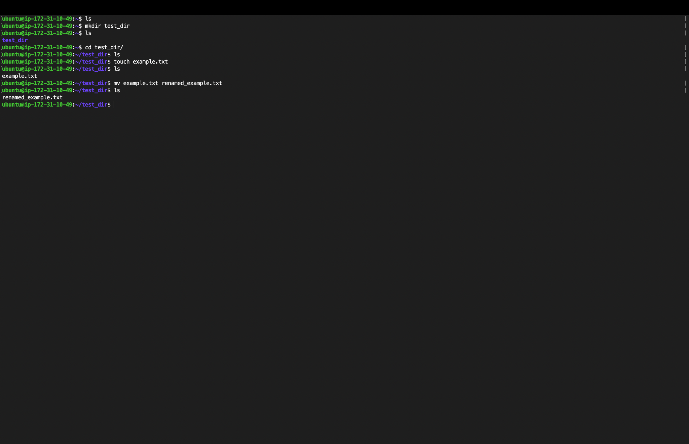

* Created a directory named test_dir using the command: mkdir test_dir
* Navigated into the test_dir directory using: cd test_dir
* Created an empty file named example.txt using: touch example.txt
* Listed the contents of the directory to verify the file was created: ls
* Renamed the file example.txt to renamed_example.txt using: mv example.txt renamed_example.txt
* Listed the directory contents again to confirm the file was successfully renamed: ls

1. Linux Basics assignment

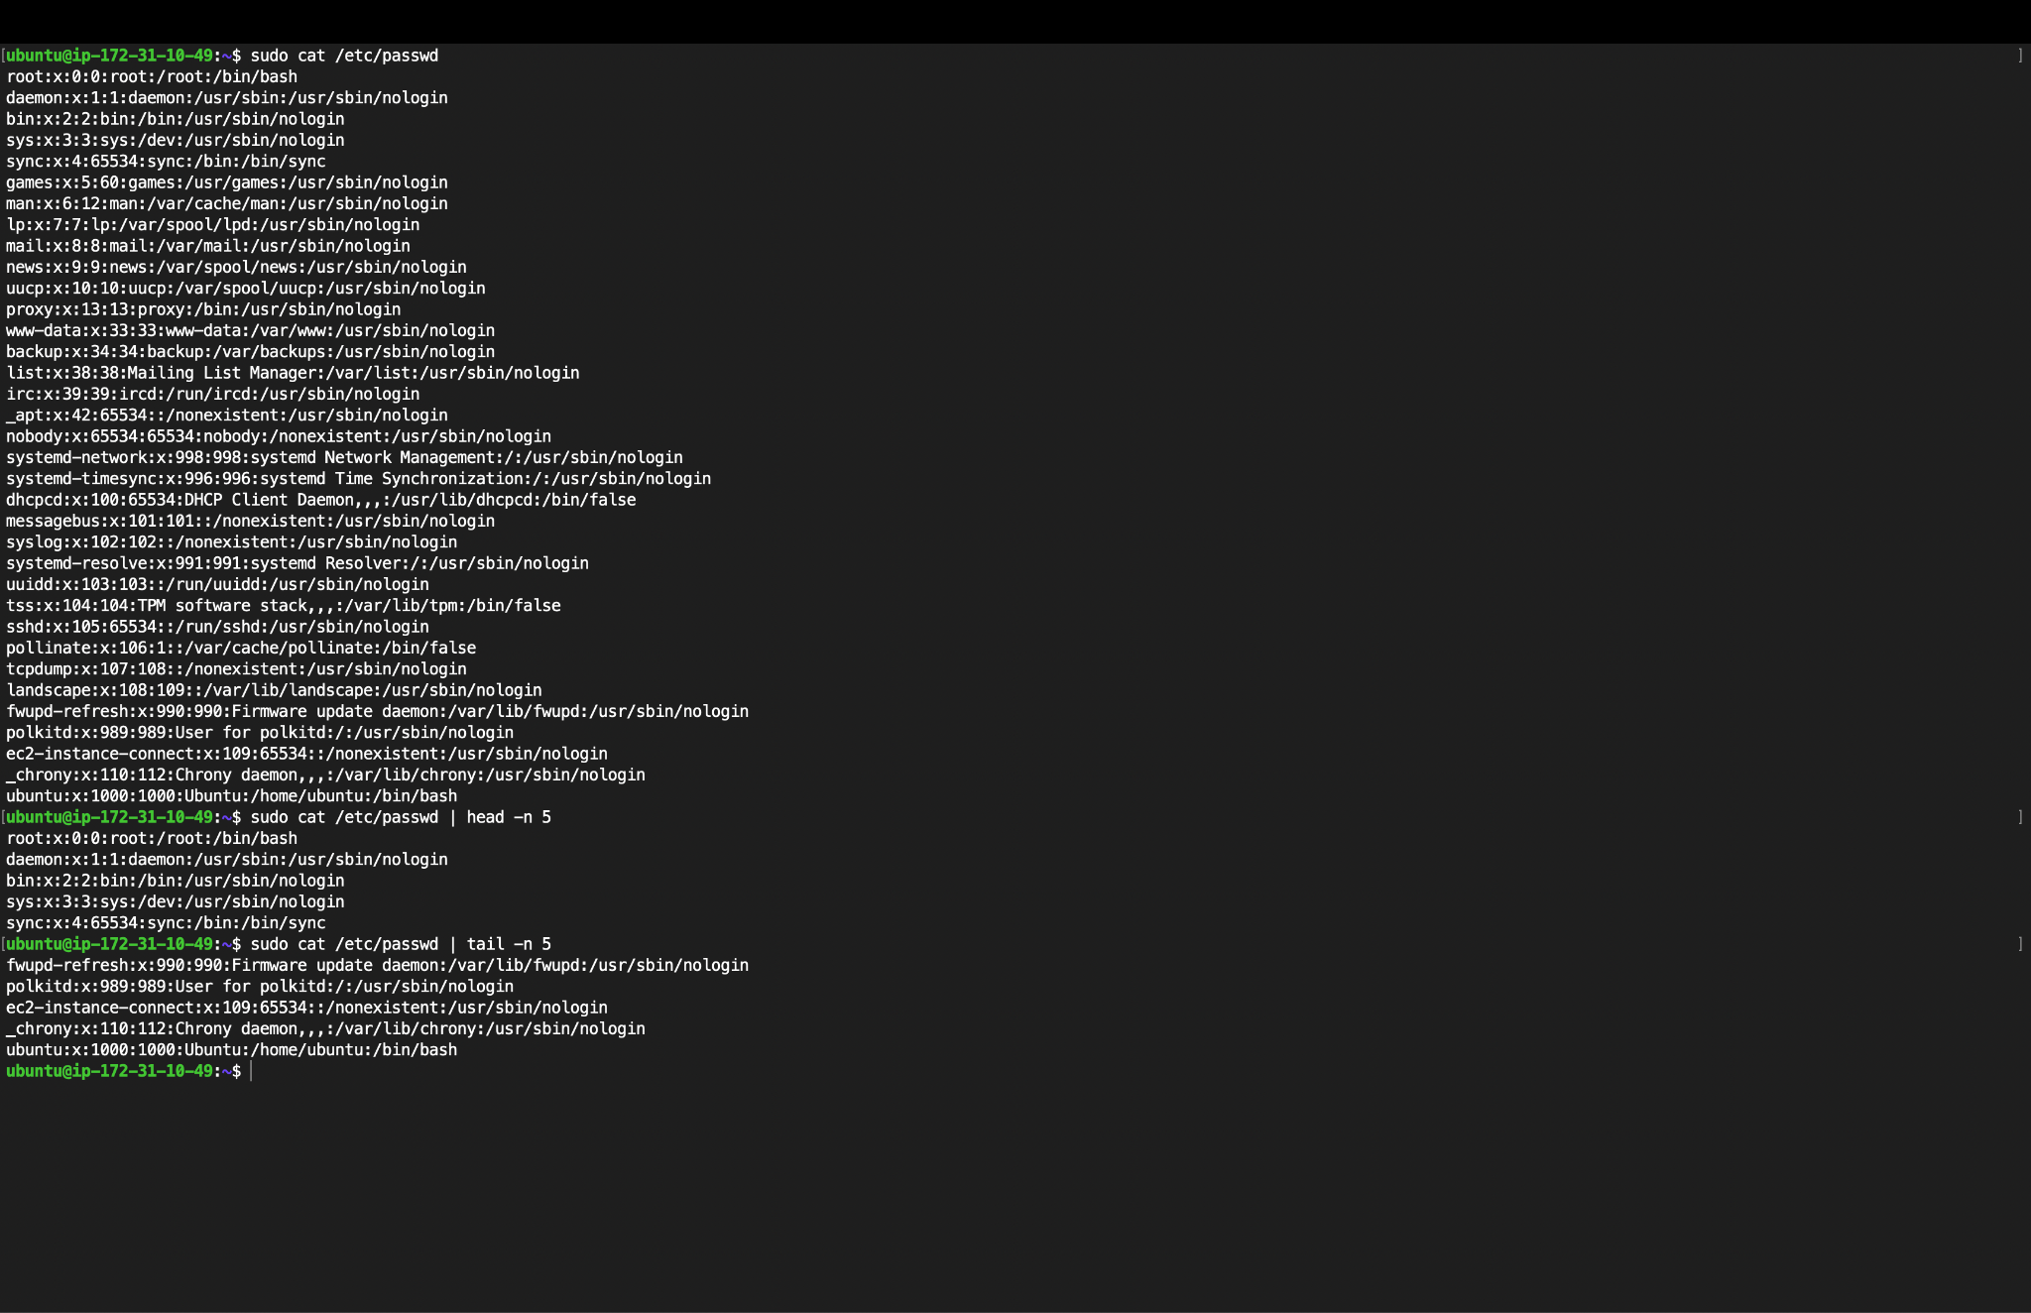

* Displayed the full contents of the /etc/passwd file using:  
    
   sudo cat /etc/passwd
* Used the head command to display the **first 5 lines** of /etc/passwd:  
    
   cat /etc/passwd | head -n 5
* Used the tail command to display the **last 5 lines** of /etc/passwd:  
    
   cat /etc/passwd | tail -n 5

1. Searching for Patterns

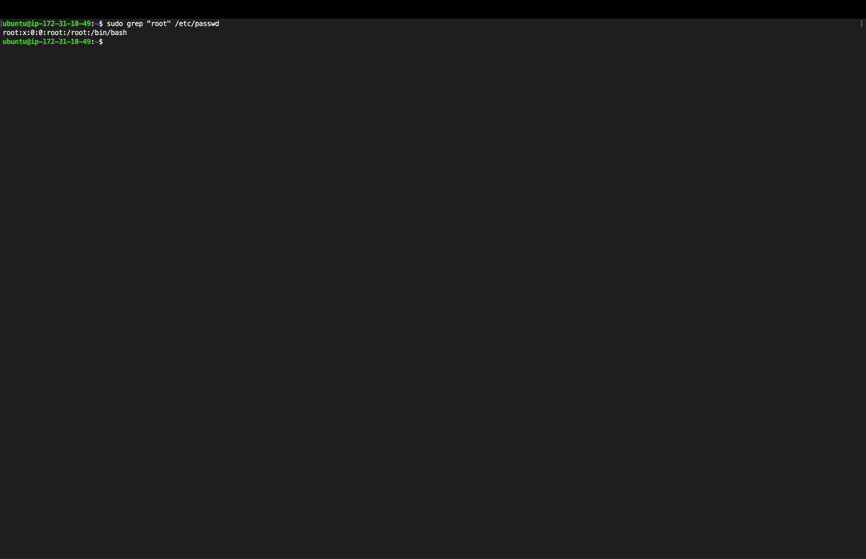

* Searched for the word "root" in the /etc/passwd file using the command:  
    
   sudo grep "root" /etc/passwd
* The command filtered and displayed only the line(s) that contain the word "root".
* The result showed the user account information for the root user:  
    
   root:x:0:0:root:/root:/bin/bash

1. Zipping and Unzipping

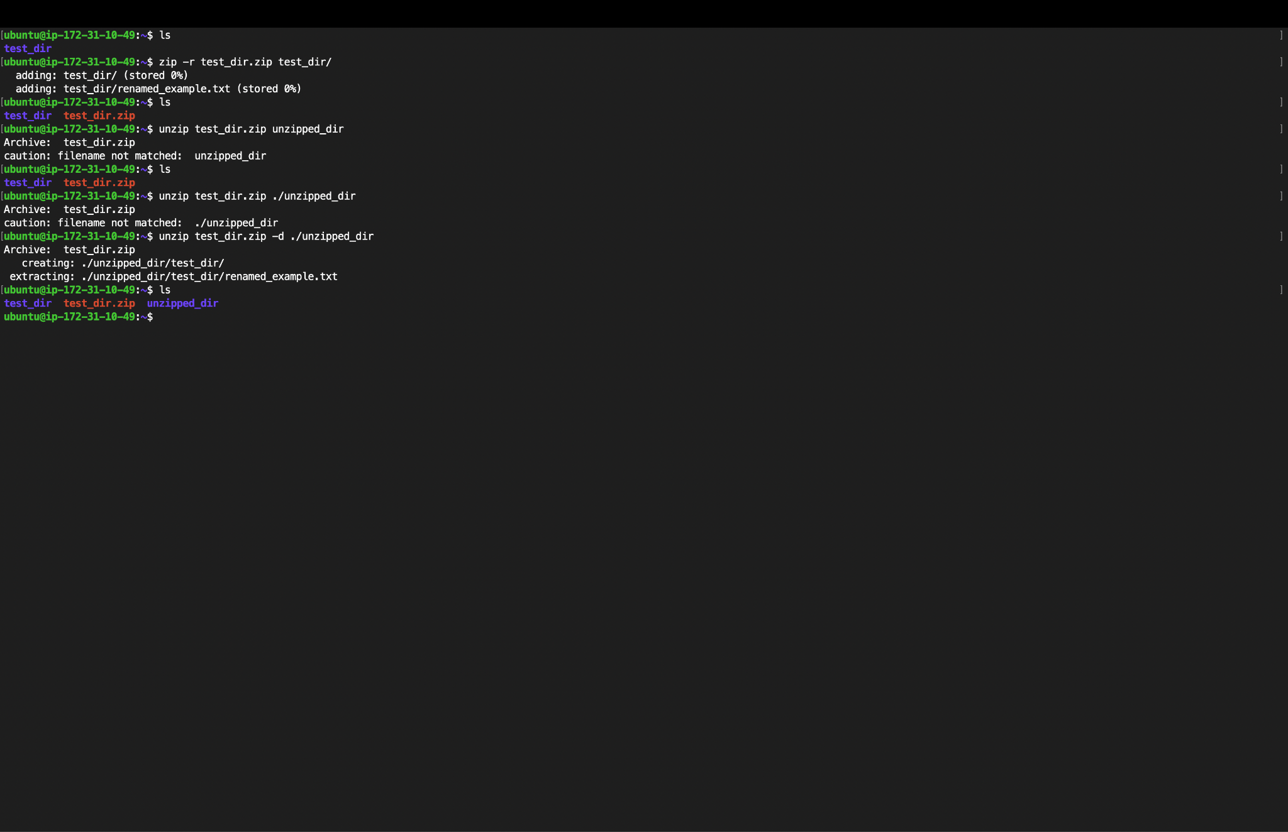

* Zipped the test_dir directory into a file named test_dir.zip using the command: zip -r test_dir.zip test_dir/
* Tried to unzip test_dir.zip by specifying a file or folder name (unzipped_dir), which didn’t exist inside the zip, resulting in a “filename not matched” warning.
* Attempted again using ./unzipped_dir, but received the same warning.
* Successfully extracted all contents of test_dir.zip into a new folder named unzipped_dir using: unzip test_dir.zip -d ./unzipped_dir
* Verified that the contents were extracted correctly and the file renamed_example.txt appeared under unzipped_dir/test_dir/

1. Downloading Files

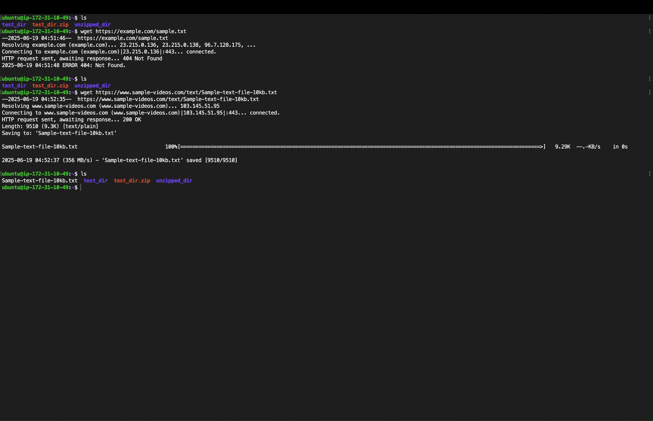

* Tried to download a file using an incorrect URL with the wget command:  
    
   wget https://example.com/sample.txt  
    
   → Resulted in a 404 Not Found error because the file did not exist at that URL.
* Successfully downloaded a sample text file using the correct URL:  
    
   wget https://www.sample-videos.com/text/Sample-text-file-10kb.txt
* The file Sample-text-file-10kb.txt was downloaded and saved in the current directory.
* Confirmed the file was downloaded by listing the directory contents using: ls

1. Changing Permissions

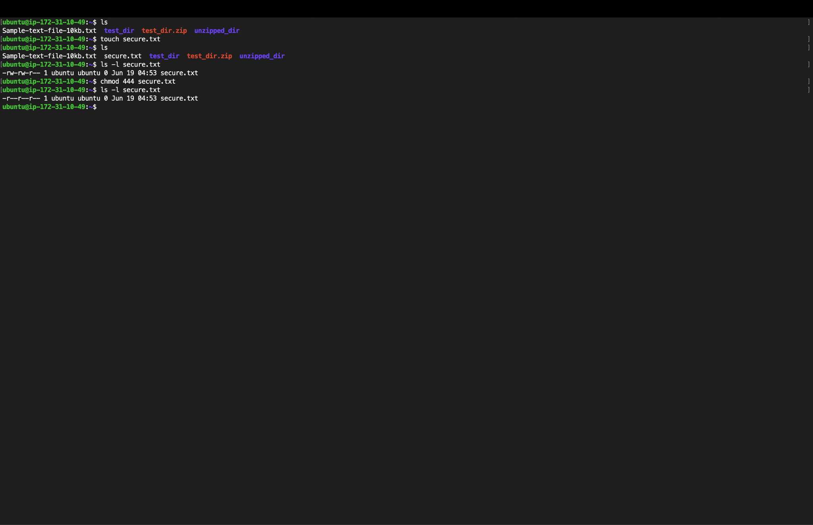

* Created a new empty file named secure.txt using the command: touch secure.txt
* Verified the file’s default permissions using: ls -l secure.txt  
    
   → The output showed default permissions as -rw-rw-r--
* Changed the permissions of the file to **read-only for everyone** using: chmod 444 secure.txt
* Verified the updated permissions again using: ls -l secure.txt  
    
   → The new permissions displayed as -r--r--r--, confirming it is now read-only for all users.

1. Working with Environment Variables

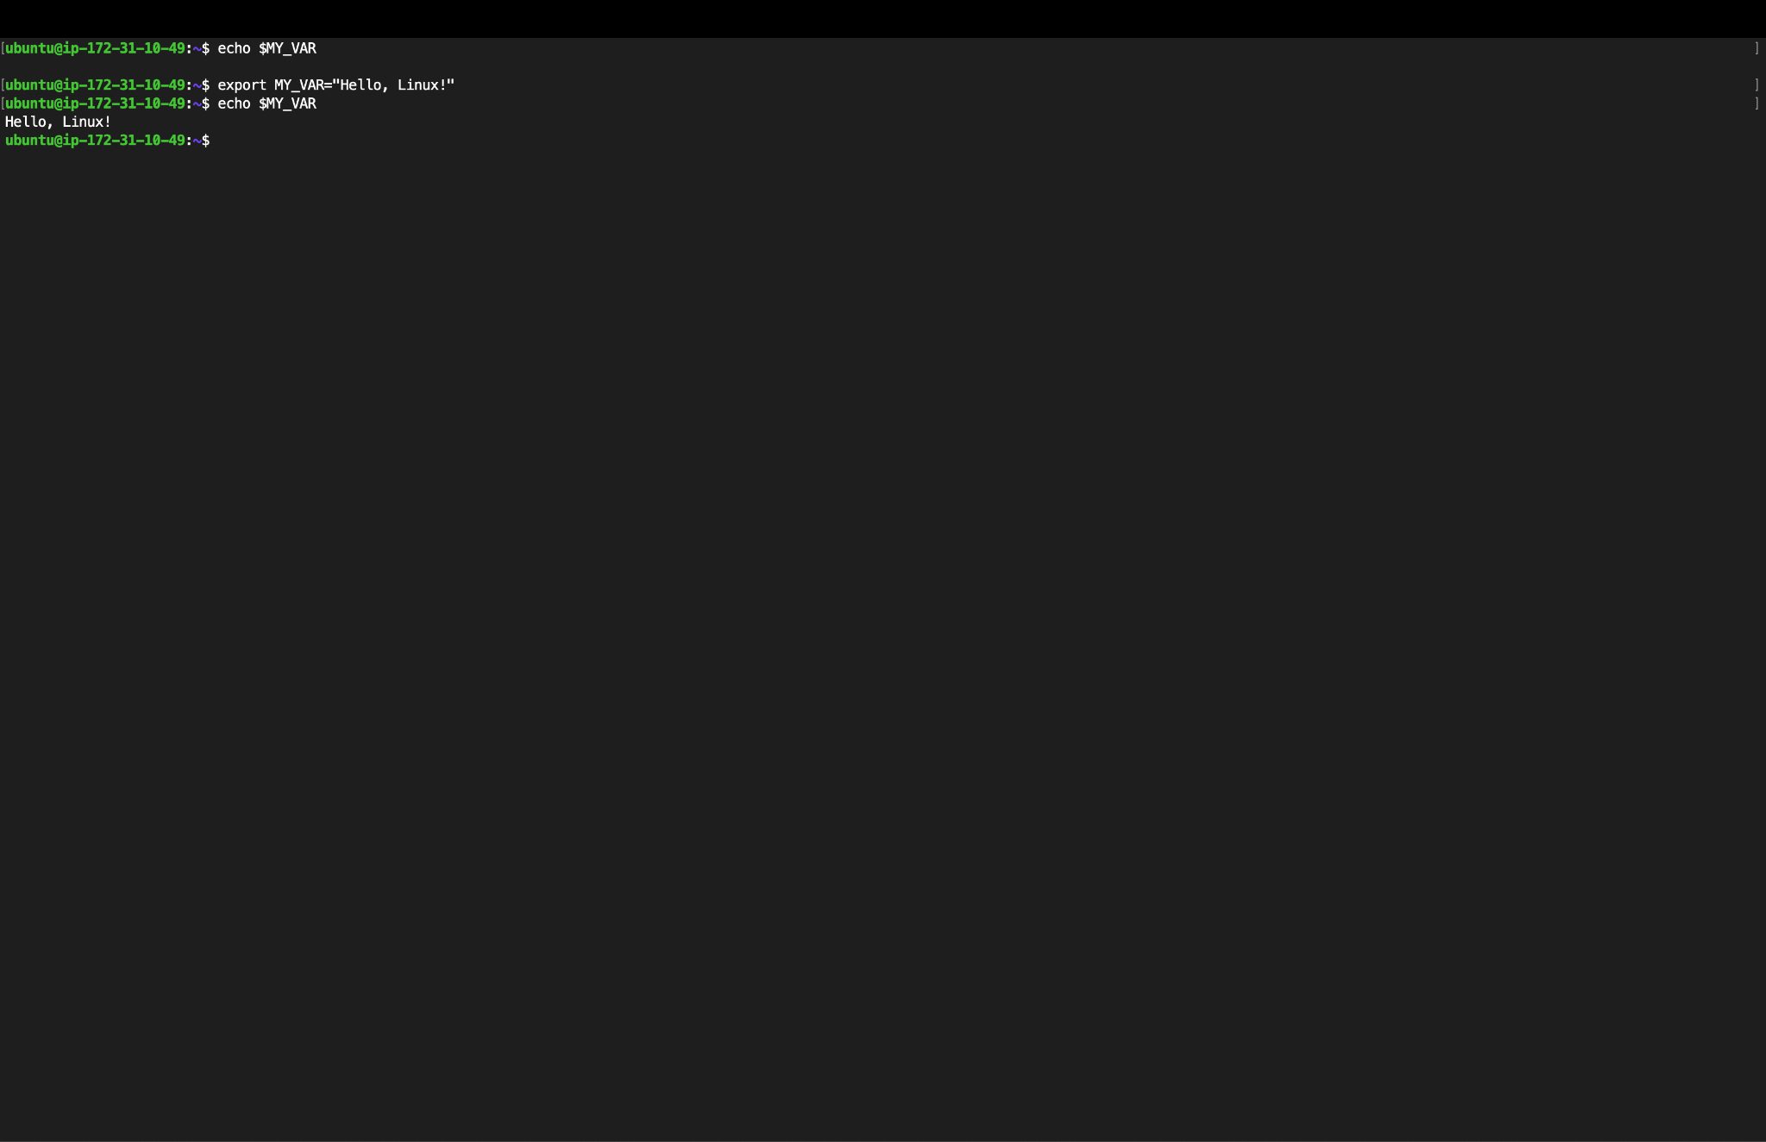

* Initially checked the value of the variable MY_VAR using the command: echo $MY_VAR  
    
   → No output was shown because the variable was not yet set.
* Created a new environment variable MY_VAR with the value "Hello, Linux!" using:  
    
   export MY_VAR="Hello, Linux!"
* Verified that the environment variable was set correctly using: echo $MY_VAR  
    
   → Output: Hello, Linux!